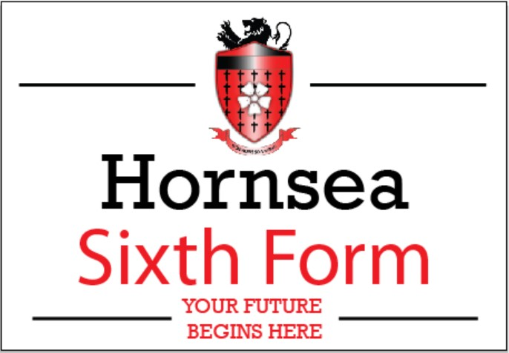
September 2022 – July 2023 Sixth Form Transport reimbursement scheme
Partial reimbursement of costs application form
Student Name

Tutor Group

Parent/Carer name

Name to be used on reimbursement cheque(s) (if different from above)
Bank Details | Bank Name | Account Name
 | Sort Code | Account Number
Paypal email address

I confirm that;
- My child attends HSLC sixth form as a full time student.

- I have attached to this form “proof of purchase” (copy of bus pass or receipt of payment/direct debit).

- I understand that I will receive 3 equal payments at the beginning of each term*
PLEASE ENSURE THIS FORM IS EMAILED TO buspass@hslc.co.uk WITH PROOF OF PURCHASE BY 12th SEPTEMBER 2022 APPLICATIONS RECEIVED AFTER THIS DATE WILL NOT BE PROCESSED

Signed _______________________ Date _______________________
*The conditions of reimbursement for payments 2 and 3 are;
- The student travels to and from school by bus (not car or motorbike) as their main means of transportation.
- The student is complying with their learning agreement
- The students attendance is no lower than 95% - Please note that only truly exceptional circumstances may be considered in mitigation but that normal medical absences will count as absence

The first payment will not be subject to any conditions and will be paid in September 2022, the second payment will be made in January 2023 and the third in April 2023 subject to the above conditions.

